Block Flow Diagram and Supplemental Data Instructions and Overview:

NOTE: The Block Flow Diagram (BFD) & Supplemental Data (SD) template is provided as a convenient method of documenting the information required to accurately assess the projects proposed in response to this FOA. The use of the BFD & SD template is not required, but the data elements presented within the BFD & SD template are required.

Instructions and Overview:
The purpose of the BFD & SD is to assess the merits of the selected technology and the status of the process technology in order to gain an understanding of project risks and the potential viability of the proposed project. Please answers all questions as thoroughly as possible based on current knowledge.

Please provide a BFD (a simplified example of a BFD can be found at the end of this PDF) for the entire envisioned process, from feedstock handling through final biofuel or product storage. Please indicate, with a dotted lined circle, which unit operation(s) will be the subject of the proposed project. Similarly, please provide the filled out Supplemental Data Template (or equivalent data) for the unit operation(s) that will be the subject of the proposed project.

It is expected that applicants describe previously collected data from their (a) existing process (lab-, bench-, or other-scale) that will be utilized during the proposed project to design and build the (b) proposed equipment / unit operations, which in turn will be used to gain process information to construct and operate a (c) fully integrated facility post project. Pay particular attention to the proposed engineering-scale equipment when answering the questions below for each unit operation. The attached BFD & SD should relate to the proposed project.

Unit Operation Step: Unit operation steps are defined as the areas in the facility where a change occurs, such as reactions, physical changes to materials including materials handling, or chemical conversions. (A physical step physically alters material, and a chemical conversion step involves changes in the molecular form of a material.) Some examples of items to be included as unit operation steps appear below:

Reactors Shredder Filters Drying
Distillation Mixers Ion Exchange Fermenters
Aerators Gas Absorption Separations Gas Cleanup

Use a unique number for each unit operation in the BFD. Show recycle loops and waste streams as well. The characteristics of each output should directly tie to input of the respective unit operation in the process. If additional processing is required before the output of one unit can be used as the input to another, an additional unit operation should be included to describe how the stream is altered. It is particularly important to focus on the heat and material balance of each block step. The description of the process should begin with the first manipulation of the feedstock in its as-received condition, such as de-stringing of baled corn stover or any initial sizing/moisture reduction of wood chips. Applicants are encouraged to summarize the process using ten blocks or fewer for an estimated level of detail.
Blow Flow Diagram & Supplemental Data Template
Provide the following information for the process shown in the BFD

- How and why was the proposed process chosen? Discuss technical and business risks, benefits and opportunities associated with the process.

- Describe the history of research and development performed by the applicant for the proposed process including scale, duration of runs, type of data collected, etc.

Answer the following questions for each Unit Operation circled in the BFD

Unit Operation # – {title}

1. Name or title (as shown in the BFD).

2. Description of the PROPOSED unit operation.

1) Capacity and throughput.
2) Provide the heat and material balance (H&MB). Specifically including, but not limited to, energy and carbon balance information.
3) Provide the processing conditions for the unit operation, including temperature, pressure, and residence time.
4) Provide designed and actual yield, conversion and efficiency data for each unit operation detailing the products, byproducts, and waste streams.
5) Provide the materials of construction and the basis for their selection for each critical piece of equipment.
6) Provide the expected service life including expected maintenance cycles.
7) Describe any known causes and the impacts of system upsets and contaminants (including the source(s) of the contaminants).
8) Provide a description, including physical and chemical composition, phase, temperature and pressure of all input and output streams.
9) Describe the mode of operation, i.e., batch, plug or continuous flow.
- For all waste streams leaving the process describe the physical and chemical composition, phase, temperature and pressure, and the proposed method of treatment, storage and/or disposal.
- Provide the estimated capital cost of each unit operation and the basis for those costs.
12) Describe the instrumentation and controls that will be incorporated into this unit. This should complement the instrumentation and controls discussion in the Project Narrative.

3. Describe the state of technology for the unit operation.

1) If the technology is commercially available, is the proposed design and use within the manufacturer’s normal operating parameters?
2) At what scale(s) has the technology been designed and tested? What is the scale-up factor for the proposed unit operation or integration step? (Scale up = proposed facility unit capacity divided by previous scale capacity.) That is, provide specific explanation and justification for the basis of assumed success in achieving the designed scale up.
3) How many runs were made at the stated scale, and for how many continuous hours/days? When (approximately) was the most recent test run?
4) If R&D is the basis for the state of technology, describe the original goals and objectives of the R&D. If not discussed in #3, above, summarize the results of the R&D and discuss how the original goals and objectives were met or not met. Describe the quality and replicability of the results. (If data quality objectives were used to set minimum data quality standards, briefly describe them.)

Is further R&D is needed? Describe the goal and summarize the work needed to obtain the needed information. In lieu of including the information here, if the work is planned to be conducted as part of the project within the scope of this application, reference the activity (preferably by task or WBS number(s)).

5) Calculate the following sustainability metrics for each unit operation commenting on both the values observed to date as well as targets for the envisioned commercial-scale facility:
- GHGs (g CO₂-e/MJ fuel) – (emissions)
- Fossil Energy Consumption (MJ fossil energy/MJ fuel product)
- Total Fuel Yield (gal/dry ton wood; GGE/dry ton wood)
- Carbon-to-Fuel Efficiency (C in fuel/C in biomass)
- Water Consumption (m³/day; gal/GGE)
- Wastewater Generation (m³/day; gal/GGE)

6) Discuss the current state of any offtake agreements and regulatory approval for any products intended to be sold. Include a discussion of any remaining regulatory approval requirements and how the proposed facility will contribute to advancing the market acceptance of the products.

Example: Simplified Block Flow Diagram with dotted circle showing unit operations that will be part of the proposed project. Block flow diagram courtesy of NREL (Humbird et. al. 2011, 4)

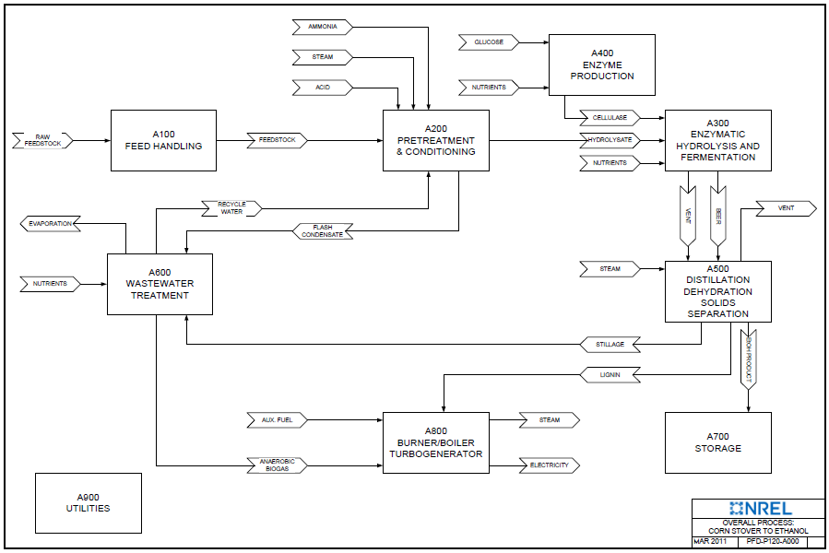

1. Humbird, D.; Davis, R.; Tao, L.; Kinchin, C.; Hsu, D.; Aden, A. Process Design and Economics for Biochemical Conversion of Lignocellulosic Biomass to Ethanol: Dilute-Acid Pretreatment and Enzymatic Hydrolysis of Corn Stover. Report No. NREL/TP-5100-47764. Golden, CO: National Renewable Energy Laboratory, May 2011. https://www.nrel.gov/docs/fy11osti/47764.pdf

